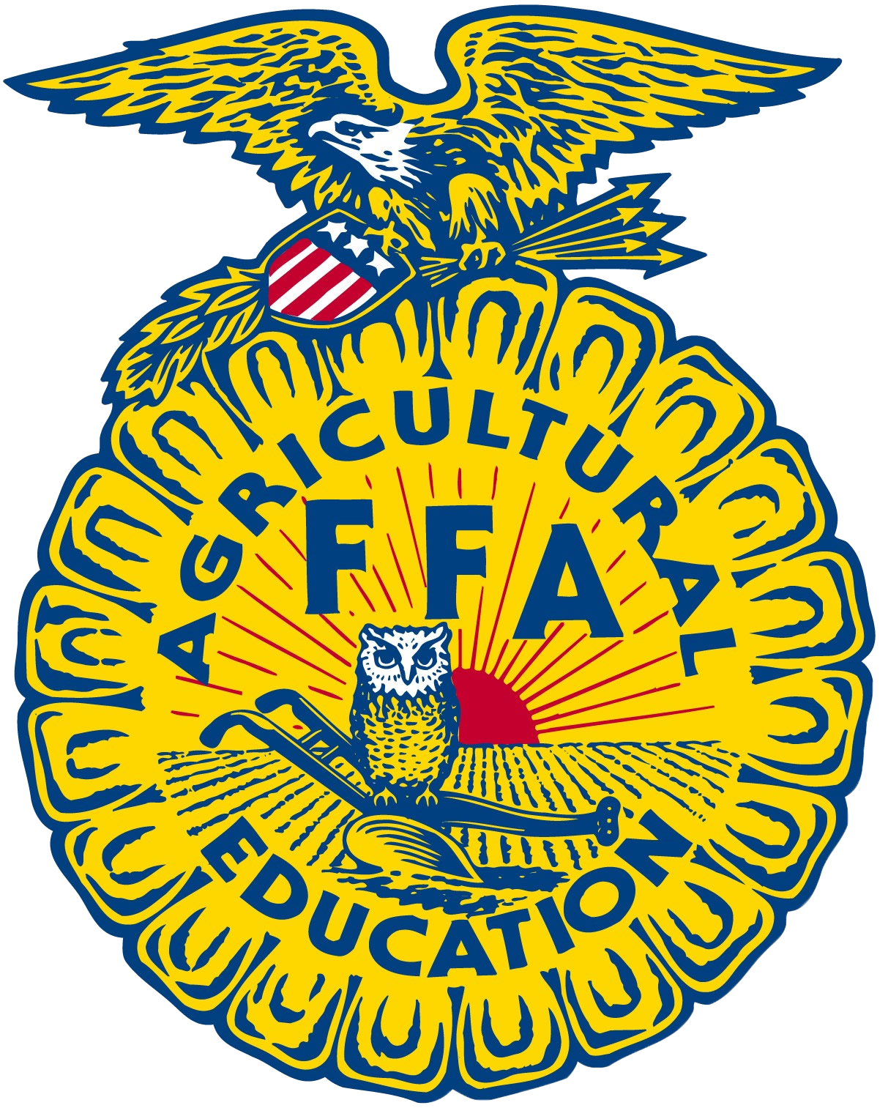
Scales Mound
Greenhand FFA Degree Application

As you complete each of the following requirements for the Greenhand FFA Degree, write the date on the line to the right.

Requirement Date Completed
- I am enrolled in an agricultural class __________________________

- I have satisfactory plans for a supervised __________________________
agricultural experience program

- I have learned and explained the FFA motto,
and salute. __________________________

- I have learned and explained the FFA creed. __________________________

- I have described and explained the meaning __________________________
of the FFA emblem and colors.

- I understand and have explained the FFA __________________________
Code of Ethics and proper use of the FFA Jacket

- I have demonstrated an understanding of the __________________________
organization’s history, and the chapter Program of Activities

- I own or have access to the Official FFA __________________________
Manual and FFA Student Handbook

Having met these requirements, I hereby submit this application for the Greenhand FFA Degree.

_________________________________________ _____________________
Member’s Signature Date

For Chapter Use
I/We have reviewed this application and certify that the candidate has met the requirements and will be awarded the FFA Greehand Degree.

___________________________________________ _____________________
Chapter Officer Signature Date

___________________________________________ _____________________
FFA Advisor’s Signature Date

Answer the Following Questions: Be sure to type your answers

Name________________________________________

Grade______________________________

School Activities and Leadership Positions:

FFA Activities and Leadership Positions:

List 5 hours of community service outside of ag class time (can be time during a blood drive shift):

Describe your Supervised Agricultural Experience (SAE):

